Diagnostic work and palpability in hand surgery

Per Linde, Tomas Sokoler and Pelle Ehn
Malmö University

Our position is that learning and communication evolve in a networked interplay between human actors and material artefacts. The role of artefacts in mediating knowledge and their ability to increase the range of what could be made visible has been highlighted by many practitioners and scholars [3,4]. Related is also the issue of how we engage in interacting with artefacts and how our actions are made visible both to ourselves and to others [6]. People’s continuous interaction with material artefacts in everyday life has a counterpart in information technologies in the way digital media supports understanding and alignment of different human actors. In two interaction design projects with the focus on supporting patient learning and empowerment with information technology we have addressed these questions. A challenge for the field of interaction design within the domain of patient learning and empowerment is to create a set of devices, services and content that can, through appropriate interaction, support the healthcare staff, the patient and his surrounding social network to collaboratively articulate the state of the injury and the necessary steps for successful patient learning. This aim—to increase articulation and visibility—needs to take in to consideration the situated nature of human action where practitioners adopt to local circumstances to manage their objectives. This is something that is highly evident in the healthcare sector where procedures are deeply embedded in diverse practices and varies depending on the patient’s situation or the local department’s available resources [5]. That procedures are situational and embedded in practice is accounted for by Bruno Latour’s writing on how we engage in talk about the body [2]. He proposes that the body becomes more and more describable as it learns to be affected by more and more entities. These entities are often artificial set ups, such as the use of medical instruments and mediating artefacts. Learning about the body is from this perspective a progressive enterprise that cannot be described only in generalizations. The deviations in individual cases have to be accounted for and aligned to the general knowledge developed within the tradition of medicine and surgery. This learning can be expressed in articulations which are propositional rather than final or general. While this ongoing learning does not have a direct impact on the diagnoses, as when it is initially defined by physicians, it does have an effect on diagnostic work since also this work is an ongoing process as treatment and rehabilitation requires constant “updating” of the diagnosis. Since many injuries have a life-long impact, the present state of the injury is as important as the initial diagnosis.

Collaboration – jointly articulating the state of the injury.

Typically rehabilitation times are very long, in specific cases up to several years. Success of rehabilitation of injury is dependent on engagement and active training by the patients themselves. Even though there is no archetypical patient, some major groups can be observed such as younger men subject to trauma, related to accidents at work, and patients around 50-60 with worn out tendons due to work related activities. This means that the process of rehabilitation most often is critical for the patient’s life-situation in a long time perspective. Patients often confront a situation in where they have a major part of their working life still ahead, but no guarantee whether they can return to their profession. In other cases everyday life situations are getting most cumbersome due to the injury. Undergoing surgery and rehabilitation you meet a variety of different actors, doctors, physiotherapists, occupational therapists etc. In addition to this, patients living in other parts of the region might consult local healthcare as well. For patients it is not uncommon to meet, and receive information from, all these actors at one single appointment at the clinic. This means that during several short-time meetings, patients might go back home with a complex set of instructions that is of importance for progress. Progress is typically slow, with low feedback mechanisms apart from staff judgments. Most of the indicators of progress or drawbacks stay in the formal patient record. Different patient narratives are common during consultations and can give information on why rehabilitation does not work. From this point of view the social dimensions of the process, for instance patients’ possibilities to adhere to instructions, are of importance.

Undergoing rehabilitation is a learning process. For the patient to learn about his condition and ways of affecting it. For the caregiver to learn about the patient’s situation and potential. This mutual learning can be supported through the notion of collaborative articulation. The concept of collaborative articulation is addressed as a situated negotiation of the state of the injury and the necessary steps for successful rehabilitation. With collaborative articulation, we do not introduce a new concept to health care. It’s rather a perspective that stresses the act of mutual agreement in consultations. Health care literature has used the terms compliance and concordance to discuss different degrees of patient empowerment. Whereas compliance refers to a traditional/conservative model where the doctor decides on the treatment and the patients should comprehend and follow instructions, concordance concerns how patients take an active stance in rehabilitation. Rather the patients participate as partners in consultations where mutual agreements are the goal. Patients understanding of their injuries and trust for the caregivers’ competence is viewed as supportive for adhering to instructions. For the caregivers it can be a challenge to understand circumstantial problems that might cause problems for the patient to follow the treatment plan. Patient narratives are one way of easing this understanding. These narratives might also have a direct impact on the diagnosis. For example a large percentage of the injuries are machine related accidents which actually are hard both to describe and visualize. Knowing details about the accident eases the understanding of the nature of the injury.

Human-matter engagement – the enactment of hand talk.

This “Hand talk”, evolving during consultations, is performed rather than spoken. A number of tools and log sheets are used to assess and monitor the flexibility of hand and fingers, grip strength, tactile sensitivity and pain. They also serve to make progress visible, which can otherwise be almost imperceptible to the patient. Therapists and physicians also use other artefacts to articulate the stories they want to tell. During a consultation, the physiotherapist uses, for example, a poster showing the anatomy of the hand to reveal and explain what kind of injury the patient suffers from. In conjunction with the poster, he complements the story by pointing at corresponding parts at his own hand. The patient might respond with a story of how he feels strange tickling when taking a shower. This in its turn urges the therapist to take a towel starting to rub the patients hand while explaining perception, pain and how he must get used to different surfaces. In many cases they use everyday metaphors or relates to the experiences of other patients. Considering this and the fact that there are specific outcomes even within the same type of injury, it is easy to see that general information is hard to use, but also to produce. The diversity of artefacts & instructions can at times cause a stressful situation for the patient in where memory easily gets overloaded.

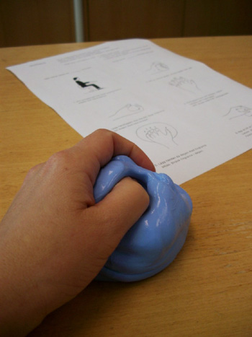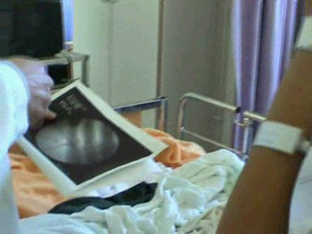
Figure 1 – From left to right, information leaflet, training tool, X-rays are all examples of representations and objects that patients must relate to.

During the patient’s trajectory of his/her recovery process and different encounters with healthcare professionals and their diverse forms of artefacts, a picture of the patient’s overall situation is gradually taking shape. From the healthcare professional’s point of view, the patient record works as a centre of gravity for this evolving image. However, in our work it became clear that the patient has no explicit tool to rely on regarding the creation of this image. And patients do have their own agendas preparing by writing down questions or just mentally going through the consultation to be.

During several instances processed data must be understood and translated by patients into “real-world” facts. One example is when patients are doing exercises in the work simulator. The work simulator is a set of machinery which simulates real activities such as climbing a ladder, driving a car etc. The strength used is measured in numbers and logged in individual sheets for each patient. The log sheets accounts for how rehabilitation is going, but can be hard to relate to actually performing the tasks in real life.

So, meetings and artefacts help the patient to form a picture of his/her recovery process. Much of the relevant information is embedded and of a situated character, revealed with the help of aligning different artefacts to the patient’s injury. The evolving picture is negotiated between the parties forming a unique story for each patient and during consultations learning and instruction is mutual and negotiated in interaction.

Human-technology engagement - dealing with heterogeneity.

Per-Anders Hillgren and Erling Björgvinsson, in the project “Everyday learning within health care”, have made promising experiments [1] to capture such situated occasions, by various ways of recording and documenting parts of consultations that can follow the patients. Digital media has the potential for easy and instantaneous documentation that renders a situated character to information. While resting in between the general and the particular, it can be related to the specific moment in which it was conveyed. In the first experiment, they used a DV camera on a tripod to film meetings between a physiotherapist and different patients recovering from the same injury (an incision to a tendon).

Another experiment from their project included the use of screen capturing software. Often during consultation sessions, a physician and a patient collaboratively watch the patient’s X-ray pictures on a computer screen between them. In those cases, the physician uses the X-ray pictures to explain what kind of surgical procedure he is planning to perform. The software used allows the physician to draw and mark the X-ray pictures to emphasize the patient’s status and what the surgical procedure will be about. All this was recorded as an animated movie together with their discussion. The case of hand surgery illustrates how a diversity of artefacts, materials and representations are used in different settings and talked about in different ways. Using complementary digital media produced on the fly during consultations, or by the patients while away from the clinic, is one way of aligning the vast amount of information.

But the interaction around the life-cycle of digital media poses several interesting questions. Sarvas et al. observes in an analysis of the mobile photo life-cycle how we must include all the involved terminals and devices and not only focus on individual devices and interfaces [7]. They emphasize how the life-cycle of mobile photos, which they describe as capture-transfer-share-view and archive, is distributed over several devices and how some of the transitions require substantial user effort. An emerging issue of connecting refers to a very practical aspect of understanding of how digital media is transferred between devices and how different devices co-operate, but there are also several social aspects involved. Collaborating within the environment, which has an lay out similar to those of open offices where many therapists share the same space, is both patients and therapists in their specific meetings, but also the whole amount of actors in the space. The issues of privacy and perception of the actions of others is a general question for every shared space, in where activities around are staged around the use of digital media.

We took as starting point to use mobile phones as central devices for interacting with an environment that has constituent resources in the form of displays, cameras and sensors and so forth. For practical reasons we used PDAs instead during implementation, since, to our experiences they are easier to program. It was important for us to keep the concept of collaborative articulation in mind, supporting empowerment of the patient while at the same time developing a useful tool for the staff. Another object we introduce in our scenarios is the metaphor of a docking station—a physical object that in combination with a phone or PDA provides a framing for fulfilling some specific intention such as recording, viewing or sharing digital media. It is motivated by desirable use qualities such as augmenting the generic device with activity-specific functionality when needed, and supporting visibility of activity and intentions. The name docking station is not an ideal name and it has also been talked about as a physical proximity descriptor or pairing device. Initially we were inspired by docking stations physical shapes and affordances, it is generally very clear to understand how to put the device in the docking station since the slots fits nicely and it has became an accepted mode of joining devices, for example a PDA to a PC.

The docking station has been designed for the sole purpose of making a video recording, but in the future it might well be developed as to have potential for other activities such as displaying or sharing. Instead of an ordinary tripod and video camera we have used a webcam of good quality mounted on a desktop lamp. This gives a quality of “physical zooming”, by moving the lamp holding the camera closer to the object of recording you zoom in and vice versa. Once the both PDAs are placed in the docking station they are connected to the camera and the video feed is displayed on the displays of the PDAs. We chose to make it necessary to use both PDAs during this first iteration as to enforce the shared decision making on what to record. As it is possible for the patient to start a recording the nature of interaction is more of a shared interface.

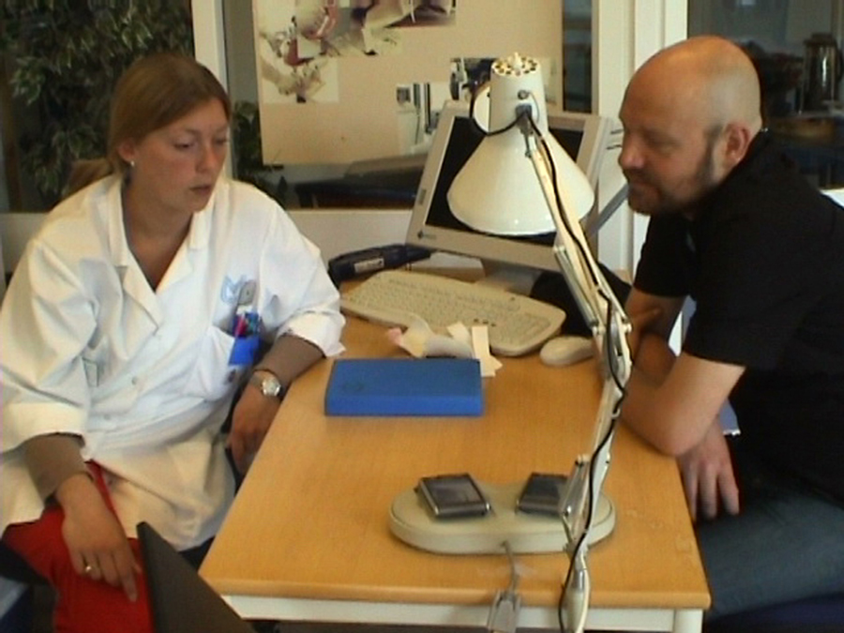
Figure 2 – Our set-up with PDAs, camera lamp and docking station.

So, instead of using the remote control for initiating and stopping the recording, the act of placing the PDA in the docking station connects it to the camera. The video feed is displayed in a low-resolution version on the PDA (which eventually also will store the media. This is not yet implemented). The screen of the touch-sensitive display replaces the record and stop buttons and tapping on the display thus controls the recording. When the PDAs are taken out of the docking station, the connection with the video camera is ended.

Though not fully evaluated in actual use at the clinic we think the design responds to a notion of very explicit interaction, which might seem unnecessary, but still has some interesting features which have been assessed in sessions with the staff;

- Placing is not a physically demanding interaction, which actually is an issue for people with hand disabilities. Neither is it a cognitive demanding task, compared with browsing for the right application and navigating in a typical PDA interface with many choices.

- It is performative in the sense that both partners can relate to a ritualistic series of actions that reflects a change of rhythm in the consultation. It is agreed that they now are about to start a recording. It also supports other people present in the room that can peripherally perceive that a recording is taking place, in adjusting how they perform for example deciding not to disturb or make loud noises.

- It is personal in as much as viewing the recording on the personally owned display gives a feeling of ownership and access to the digital media.

But what is more important; the collaborative nature of interactions enforces the shared and negotiated nature of the decision on when to record and what to record.

References

1.Björgvinsson, Erling and Hillgren, Per-Anders (2004), On the spot experiments within healthcare, in proceedings of the eighth conference on Participatory design: Artful integration: interweaving media, materials and practices - Volume 1, ISBN:1-58113-851-2

2. Latour, Bruno (2004), How to Talk About the Body? The Normative Dimension of Science Studies , Body & Society © SAGE Publications (London, Thousand Oaks and New Delhi),Vol.10(2–3) 205–229.

3. Jean Lave and Etienne Wenger (1991) Situated learning. Legitimate peripheral participation. Cambridge University Press

4. Heath, Christian. 1988. Embarrassment and Interactional Organization. In Paul Drew and Anthony Wooton (Editors), Erving Goffman: Exploring the Interaction Order. Cambridge: Polity.

5. Mol, A and Berg M (1998 ), An introduction, Differences in Medicine, Duke University Press.

6. Robertson, Toni (2002)., The Public Availability of Actions and Artefacts, in Computer Supported Cooperative Work 11 Kluwer Academic Publishers. Printed in the Netherlands. 299–316.

7.Sarvas, Risto, Oulasvirta, Antti and Jacucci, Giulio (2005), Building Social Discourse Around Mobile Photos – A Systemic Perspective, in proceedings of MobileHCI'05, pp.31-38, September 19–22, , Salzburg, Austria

